Triggered incident through pagerduty API :

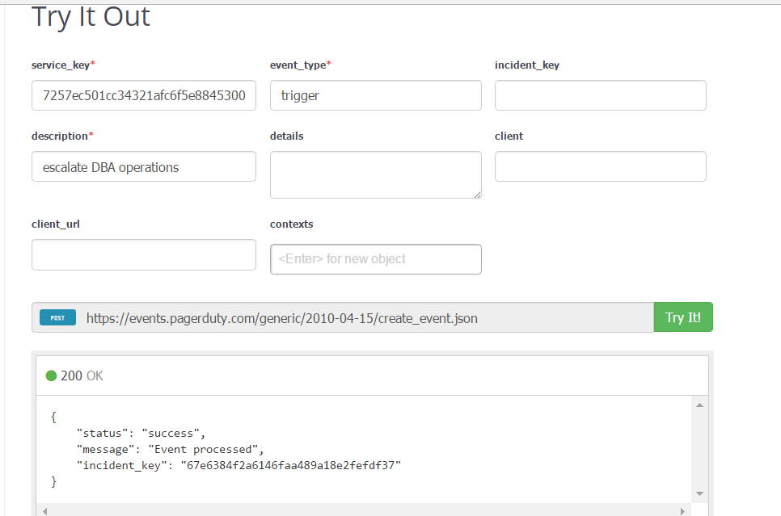

Message in spark :

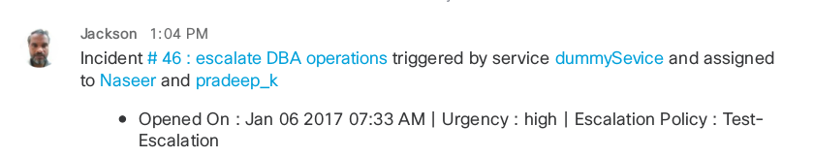

Incident Details in pagerduty :

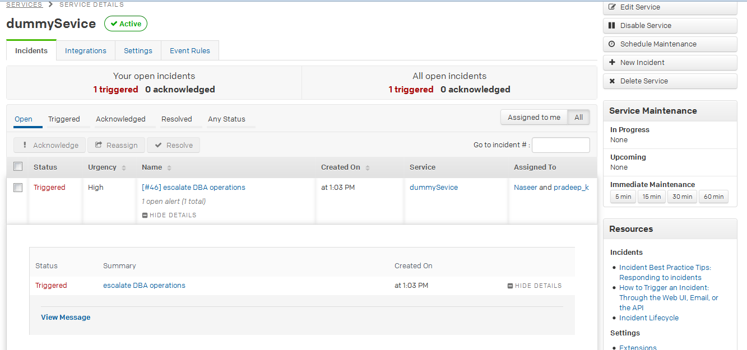

====================================================================================

Triggered incident through generic webhook :

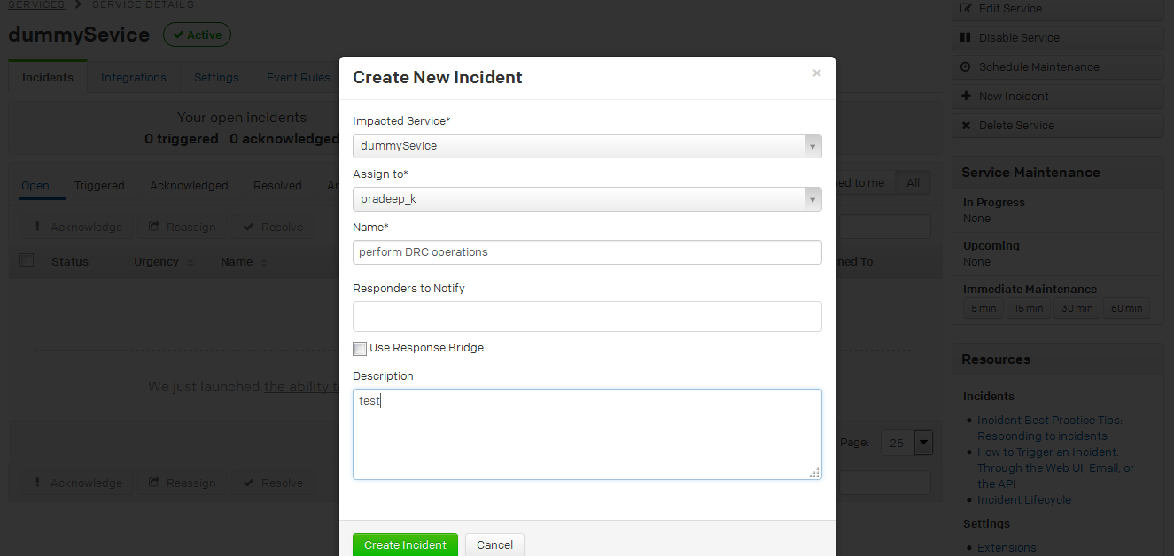

Spark Message :

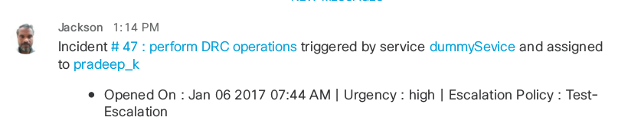

Incident Details :

